Deighton AR System: Technical Design
  - John Lyon-Smith - February 2, 2018

Goal
Briefly stated, the goal of the system is to provide a training application that incorporates augmented reality, geo location services and map data to place artificial work orders, inspections and customer complaint activities in a specific geographic area.

Architecture
The following diagram shows an overview of the software components of the system:

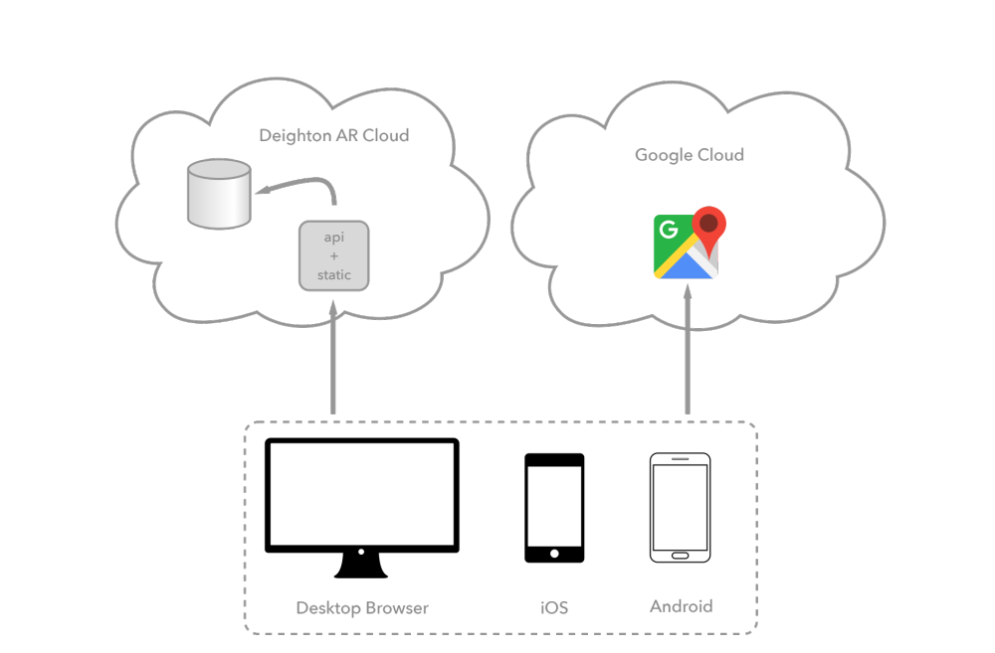
Deighton AR System Overview
As with most systems, we have cloud based services and two types of clients; mobile and desktop. On the mobile side are iOS and Android based phones (not tablets). On the desktop side we will support Chrome, Firefox and Safari and Edge browsers. Very recent versions of Internet Explorer may also work, but will not be specifically tested.
For the cloud services, we have the Deighton AR API and Google API for map data. The Deighton AR is hosted on a server that provides REST API functionality, static resources and dynamically (uploaded) resources such as photographs and recorded audio.
Hosted behind the Deighton AR API is a database that is used to record user data, team information, work orders, LEM’s, etc. as well as providing a structured blob store for photographs & audio.
We refer to the above diagram in the following sections, where we break down specific technology choices made for the system.

Technology
Working from the frontend to the backend we propose the following technologies for building the system, presented here with justification for each choice.

Website
The administrative website will be built with React as a client side, single page application. React is a modern technology, and is currently one of the most popular development frameworks after Angular. It’s well supported by Facebook and has just received a major update that reduces size and performance.
Alongside React we utilize WebPack for constructing an optimized & minimized and payload to the browser, as well as enhanced development with such features as auto-page reload during development. We also utilize npm for package management.
We will integrate SASS into the build chain as a it provides powerful features for skinning the application. We will utilize React SemanticUI and corresponding controls and styles to skin the app.
Within the React app we will utilize libraries such as React Router for navigation through the system. We’ll also utilize 3rd party components for Google Maps integration, most likely the react-google-maps component.

Mobile
For the mobile apps, we will utilize React Native. This is a React based technology that provides rapid cross platform development on iOS and Android. React Native by default utilizes the Expo system that will allow for rapid delivery of prototypes outside of the sometimes-lengthy Apple approval process for applications.
For components within the app, we will utilize the mobile version of React Router. AR functionality will be provided by the Viro AR component. Not only does this provide the platform specific AR implementations, but it also provides command line tools for process the industry standard FBX file format into embeddable 3D models. For Google Maps integration, we will utilize the react-native-maps node package.
The mobile app will communicate to the Deighton AR API using built in Fetch library, using a small number of classic JSON style REST calls, but GraphQL will be the primary protocol format. This is a modern way to implement an API query language and while there is a small learning curve, it is surprising easy to implement and will result in a much smaller code base to maintain going forward.

Deighton Cloud
The Deighton API will be built on top of three major software components. Firstly, a configured nginx server will provide load balancing and HTTPS decoding. Second, Node & Express based processes will provide GraphQL and API decoding. Thirdly, a MongoDB database will provide structured document and blob storage for the system.
Putting a well-tested web server such as nginx on the web facing sided of the system minimizes security concerns, as well as providing load balancing. It also makes the system more performant as HTTPS requests are decrypted at the front side of the system. Internally there is no need to encrypt communications as long as the system itself is secure.
Utilizing Node as the main workhorse enables access to the huge number of pre-build packages, including MongoDB ORM libraries such as Mongoose, as well as pre-built GraphQL implementations, and ready-made, fully tested security and access management packages.
MongoDB is preferred for database storage because of its simplicity. Being schema-less enables the system to easily evolve, and means that the type safety can be applied in the ORM layer. Setup and configuration of MongoDB systems is a breeze.
Finally, these technology choices allow us to easily and reliably host the system on low cost Ubuntu based Linux servers.

General
All system code will be written in JavaScript using ECMAScript 2015 (ES6) functionality. This includes asynchronous coding constructs such as promises, async/await, generators, classes, destructuring, etc.. Also, because of the use of React we will of course utilize JSX. Cross compilation to JavaScript that is supported by the targeted browsers will be done using the Babel transpiler.
Map imagery for both mobile and web comes from the Google Map API. It’s not expected that we will hit the usage limits for this API in this project.
Live debugging of all system components is achieved easily with Chrome or Firefox.

Future
In future, it would be straightforward to implement Google Analytics or some other instrumentation mechanism to gather metrics for the system.

